Full Stack Development with MERN
Project Documentation Format

1.Introduction
- Project Title : UCab
- Team Members :
S.No | Name | Mail | Roles
1 | Nallamilli Rajasri | rajasrinallamilli138@gmail.com | Frontend Development
2 | Thota Venkata Naga Durgaprasad | tvndprasad05@gmail.com | Backend Development , DataBase
3 | Kota Charan Sai Srinivas | kotacharansaisrinivas@gmail.com | Frontend Development
4 | Dama Sisindri Babu | ajaydama666@gmail.com | DataBase

2.Project Overview
- Purpose :
The purpose of the “UCab” is to provide a simple, secure, and efficient platform for booking cab rides online. The application connects users, drivers, and administrators through a centralized system, making the booking process faster and more convenient. It eliminates the need for manual ride booking by enabling users to search for available cabs, book rides, and manage their bookings, while allowing administrators to oversee users, drivers, cabs, and bookings through a dedicated dashboard
- Features :
- User registration and secure login using JWT authentication.
- Role-based access for Admin, User, and Driver.
- Browse available cabs with vehicle details and pricing.
- Book a cab by selecting pickup and drop locations.
- View and manage booking history.
- Cancel bookings before ride completion.
- Driver dashboard to view and manage assigned rides.
- Admin dashboard for managing users, drivers, cabs, and bookings.
- CRUD operations for cab and driver management.
- Secure password encryption using bcrypt.
- Responsive and user-friendly interface built with React.
- RESTful APIs developed using Node.js and Express.js.
- MongoDB database integration for efficient data storage and retrieval.
- Input validation, error handling, and protected routes for enhanced security.
3.Architecture :
- Frontend (React)
The frontend of the UCab is developed using React.js, providing a responsive and interactive single-page application (SPA). The application is organized into reusable components such as the Landing Page, Authentication, User Dashboard, Driver Dashboard, Admin Dashboard, Cab Management, and Booking Management. React Router is used for seamless navigation between pages, while Axios handles communication with the backend APIs. Role-based access control ensures that users, drivers, and administrators can only access their respective dashboards and functionalities.

- Backend (Node.js & Express.js)
The backend is built using Node.js and Express.js, following a RESTful API architecture. Express manages routing, middleware, and request handling for different modules, including authentication, users, drivers, cabs, and bookings. JWT (JSON Web Token) is used for secure authentication and authorization, while bcrypt encrypts user passwords before storing them in the database. The backend performs CRUD operations, validates incoming requests, handles errors, and securely communicates with the MongoDB database using Mongoose.

- Database (MongoDB)
The application uses MongoDB as its NoSQL database, with Mongoose serving as the Object Data Modeling (ODM) library. Data is organized into separate collections for Users, Drivers, Cabs, and Bookings. Each collection stores relevant information such as user details, driver information, cab specifications, booking details, ride status, and timestamps. Mongoose schemas define the structure of each collection, ensuring data validation and consistency. The backend interacts with MongoDB to perform efficient CRUD operations, authenticate users, manage cab availability, assign rides, and maintain booking records.

4. Setup Instructions :
- Prerequisites
- Node.js (v22)
- npm (comes with Node.js)
- MongoDB (MongoDB Atlas)
- Git
- Visual Studio Code (IDE)
- A modern web browser (Google Chrome)
- Installation :
- Clone the Repository
- Install Backend Dependencies
- Install Frontend Dependencies
- Configure Environment Variables
- Start the Backend Server
- Start the Frontend
- Access the Application
5. Folder Structure :
- Client :
The client folder contains the React application responsible for the user interface. It is organized into reusable components, pages, assets, and services to ensure maintainability and scalability.

client/
└── cab-frontend/
├── public/ # Static files
├── src/
│ ├── assets/ # Images, icons, and styles
│ ├── components/ # Reusable React components
│ │ ├── admin/ # Admin components
│ │ ├── driver/ # Driver components
│ │ ├── user/ # User components
│ │ └── common/ # Shared components
│ ├── pages/ # Application pages
│ ├── services/ # API calls using Axios
│ ├── utils/ # Helper functions
│ ├── App.jsx # Main application component
│ ├── main.jsx # Entry point
│ └── index.css # Global styles
├── package.json
└── vite.config.js

Description:
- assets/ – Stores images, logos, and other static resources.
- components/ – Contains reusable UI components categorized by Admin, Driver, User, and Common modules.
- pages/ – Holds the main application pages displayed through React Router.
- services/ – Manages API requests and backend communication.
- utils/ – Contains utility and helper functions.
- App.jsx – Defines application routes and overall layout.
- main.jsx – Entry point that renders the React application.
- Server :
The server folder contains the backend developed with Node.js and Express.js. It follows a modular architecture where routes, controllers, models, and middleware are separated for better code organization.

server/
├── config/ # Database configuration
├── controllers/ # Business logic
├── middleware/ # Authentication & error handling
├── models/ # MongoDB (Mongoose) schemas
├── routes/ # API routes
├── uploads/ # Uploaded files (if applicable)
├── .env # Environment variables
├── server.js # Application entry point
├── package.json
└── README.md

Description:
- config/ – Contains MongoDB connection configuration.
- controllers/ – Implements the business logic for users, drivers, cabs, and bookings.
- middleware/ – Handles JWT authentication, authorization, validation, and error handling.
- models/ – Defines Mongoose schemas for Users, Drivers, Cabs, and Bookings.
- routes/ – Provides REST API endpoints for authentication, cab management, booking management, drivers, and users.
- uploads/ – Stores uploaded files such as profile images or documents (if used).
- server.js – Initializes the Express server, middleware, routes, and database connection.

6. Running the Application
  - Frontend: npm run dev in the client directory.
  - Backend: npm run dev in the server directory.
7. API Documentation :
- Method | - Endpoint | - Description
- POST | - /api/auth/register | - Register a new user account.
- POST | - /api/auth/login | - Authenticate a user and return a JWT token.
- GET | - /api/users/profile | - Retrieve the logged-in user's profile information.
- PUT | - /api/users/profile | - Update the logged-in user's profile details.
- GET | - /api/cabs | - Retrieve the list of all available cabs.
- GET | - /api/cabs/:id | - Retrieve details of a specific cab.
- POST | - /api/cabs | - Add a new cab (Admin only).
- PUT | - /api/cabs/:id | - Update the details of an existing cab (Admin only).
- DELETE | - /api/cabs/:id | - Delete a cab from the system (Admin only).
- GET | - /api/bookings | - Retrieve all bookings (Admin).
- GET | - /api/bookings/user | - Retrieve booking history of the logged-in user.
- POST | - /api/bookings | - Create a new cab booking.
- PUT | - /api/bookings/:id/status | - Update the booking or ride status.
- DELETE | - /api/bookings/:id | - Cancel an existing booking.
- POST | - /api/drivers/register | - Register a new driver (Admin only).
- POST | - /api/drivers/login | - Authenticate a driver and return a JWT token.
- GET | - /api/drivers | - Retrieve all registered drivers (Admin).
- GET | - /api/drivers/bookings | - Retrieve rides assigned to the logged-in driver.
- PUT | - /api/drivers/bookings/:id | - Update the status of an assigned ride.
- DELETE | - /api/drivers/:id | - Remove a driver from the system (Admin only).
- POST | - /api/admin/login | - Authenticate the administrator.
- GET | - /api/admin/dashboard | - Retrieve dashboard statistics such as users, drivers, cabs, and bookings.
- GET | - /api/admin/users | - Retrieve all registered users.
- DELETE | - /api/admin/users/:id | - Delete a user account.

8. Authentication :
The Cab Booking System implements a secure authentication and authorization mechanism using JSON Web Tokens (JWT) and bcrypt for password protection. The system follows Role-Based Access Control (RBAC) to provide different levels of access for Users, Drivers, and Administrators.
User Authentication Process
- A user, driver, or administrator registers by providing the required details.
- The password is encrypted using bcrypt before being stored in the MongoDB database.
- During login, the entered password is compared with the encrypted password stored in the database.
- If the credentials are valid, the server generates a JWT (JSON Web Token) containing the user's ID and role.
- The generated token is returned to the client and stored securely (e.g., in local storage or session storage).
- For every protected API request, the client includes the JWT in the Authorization header using the Bearer token format.
- The backend verifies the token before allowing access to protected resources.

Authorization
The application uses Role-Based Access Control (RBAC) to restrict access to different functionalities.
- User
  - Register and log in.
  - View available cabs.
  - Book and cancel rides.
  - View booking history.
  - Manage personal profile.
- Driver
  - Log in to the driver dashboard.
  - View assigned bookings.
  - Accept or update ride status.
  - Complete assigned trips.
- Admin
  - Access the admin dashboard.
  - Manage users, drivers and cabs.
  - View and manage all bookings.
  - Monitor overall system activity.
The backend checks the user's role after verifying the JWT and grants access only to authorized endpoints.
Password Security
- Passwords are hashed using bcrypt before being stored in MongoDB.
- Plain-text passwords are never stored in the database.
- During login, bcrypt compares the entered password with the stored hash for secure authentication.

Session Management
The application uses JWT-based stateless authentication, so no server-side session data is maintained. Authentication information is stored within the signed token, making the application scalable and reducing server memory usage.

Security Measures
- JWT-based authentication for secure API access.
- Password hashing using bcrypt.
- Role-based authorization for Users, Drivers, and Admins.
- Protected API routes accessible only with a valid JWT.
- Input validation to prevent invalid or malicious requests.
- Proper error handling for unauthorized and forbidden access.
- Secure communication between the frontend, backend, and MongoDB database.
9. User Interface :
Landing Page
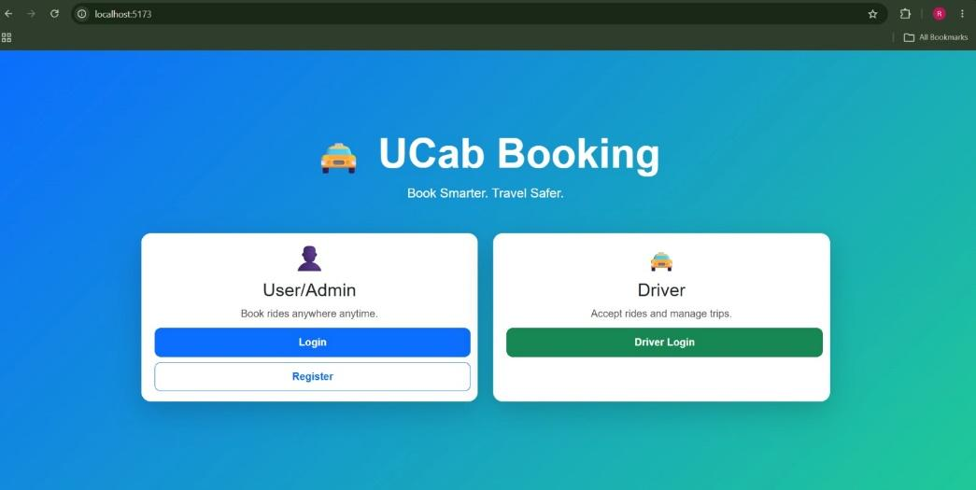
Admin DashBoard
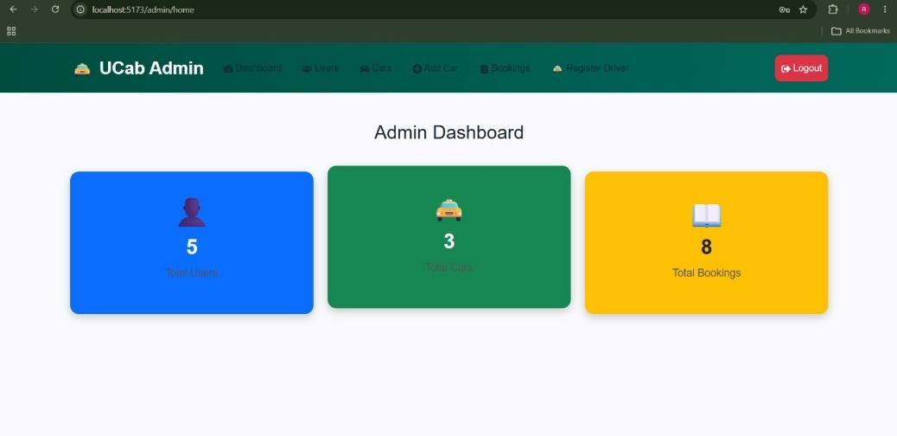
Users in admin portal
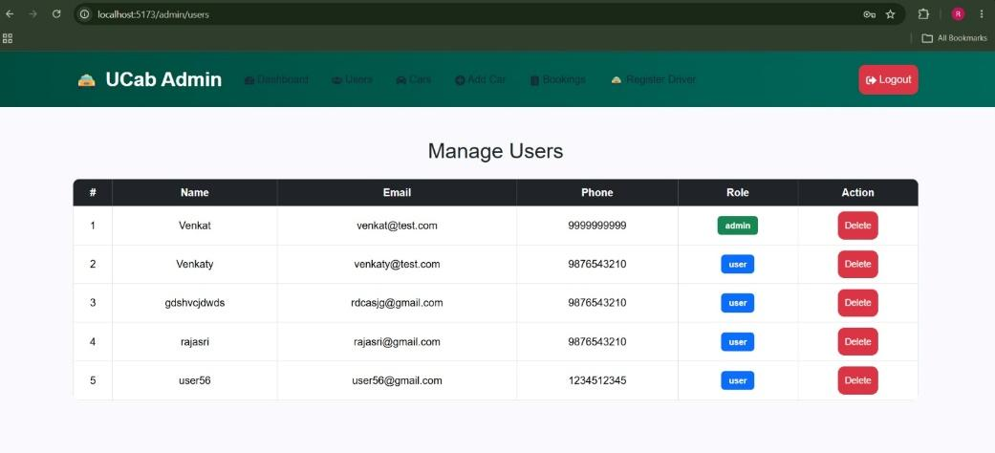
Cars in admin portal
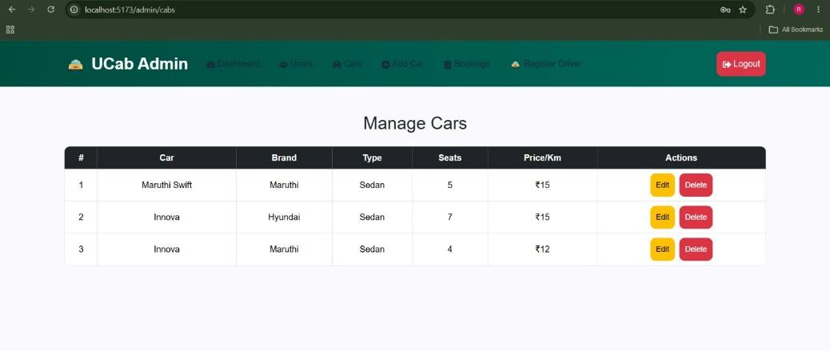

All Bookings in admin portal
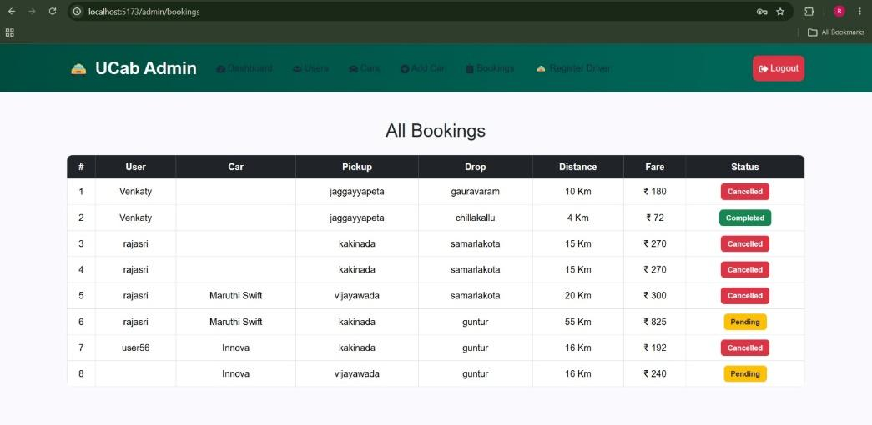
Add Car via admin
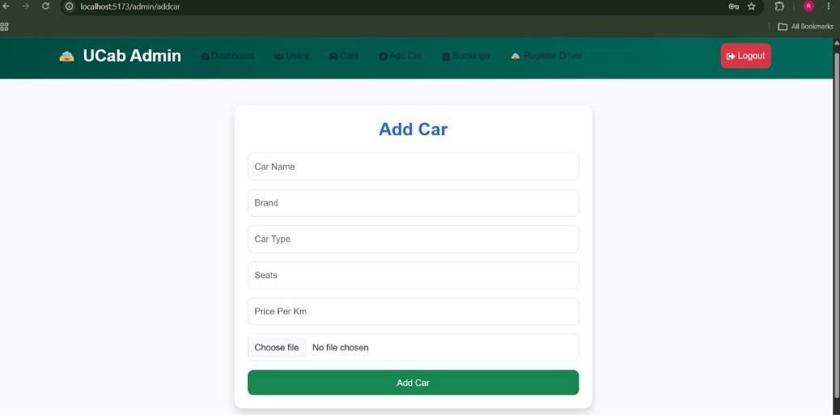
Driver registration by admin
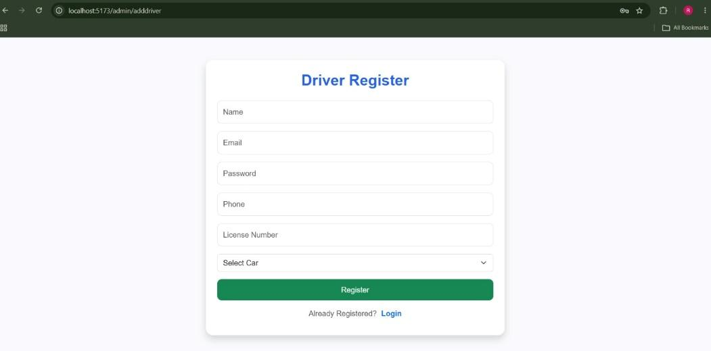
User register
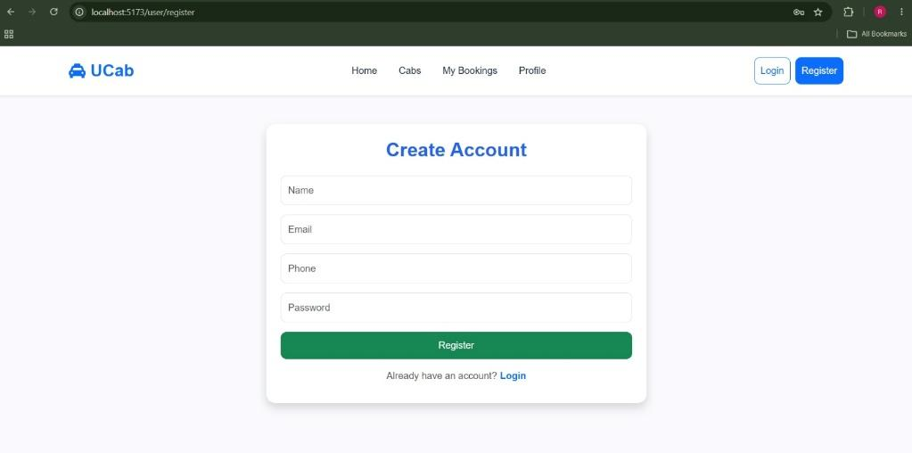
User /admin login
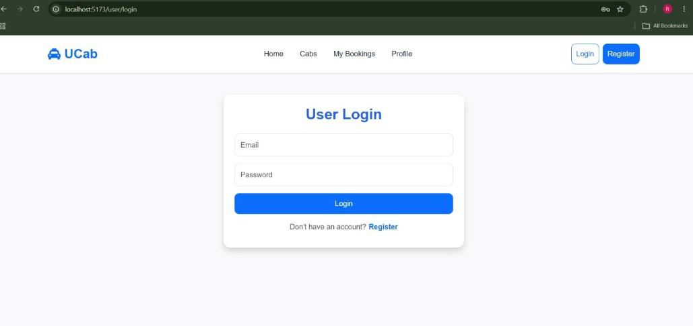
User Dashboard
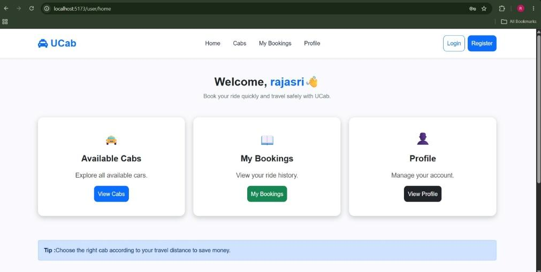
Shows available cabs to the user
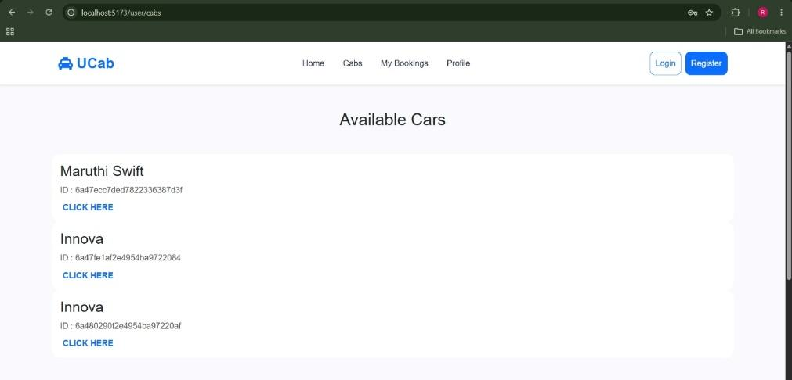
User bookings
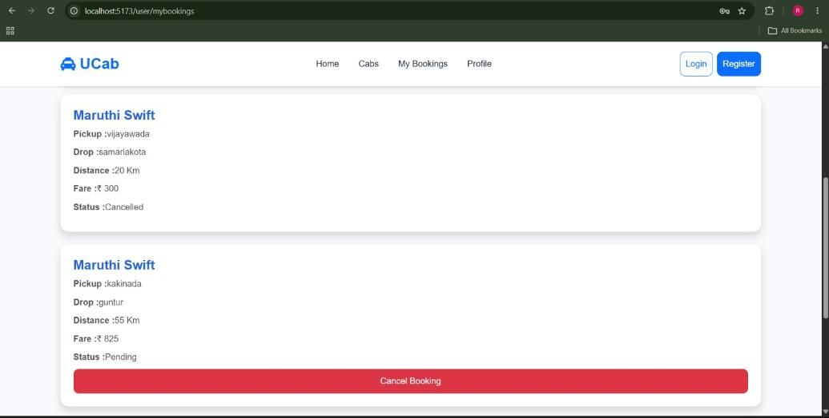
User Profile
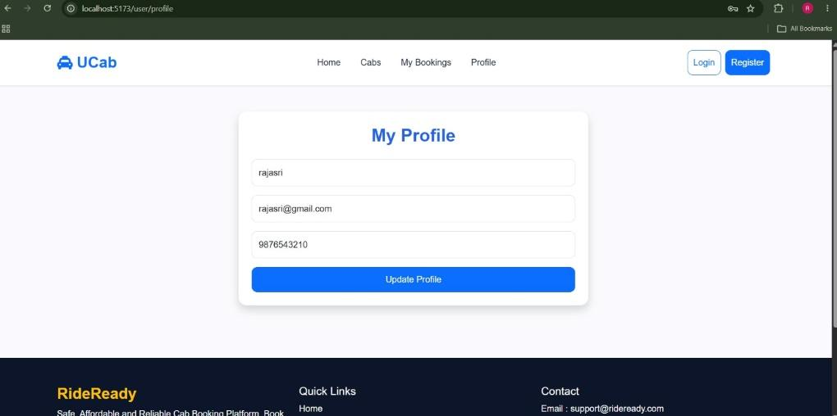
Driver login
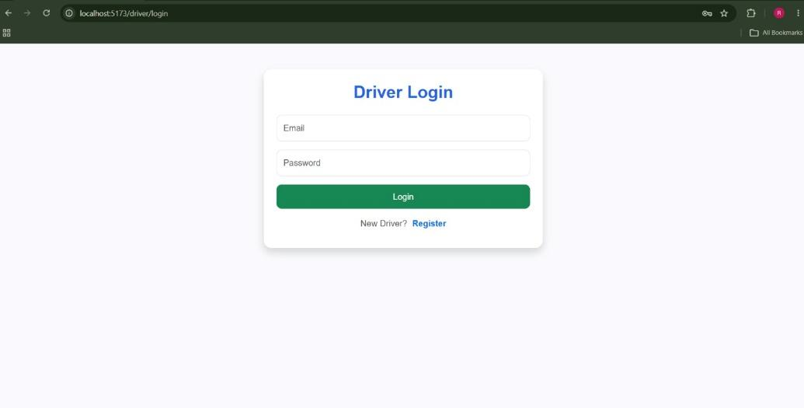
Driver Dashboard
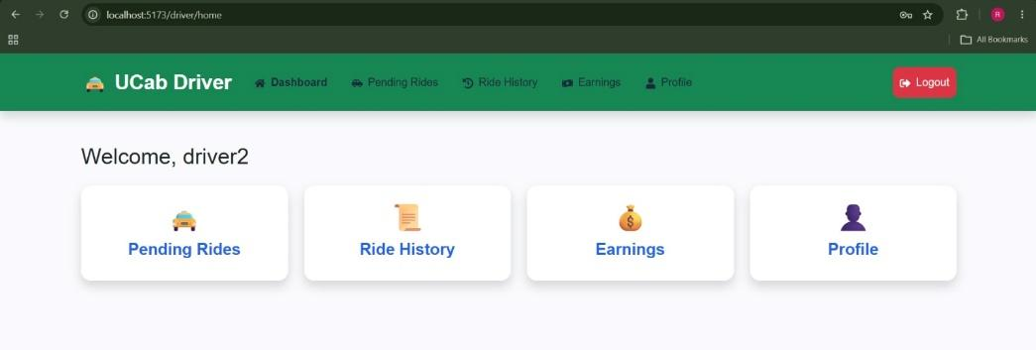
Driver ride status (pending rides )
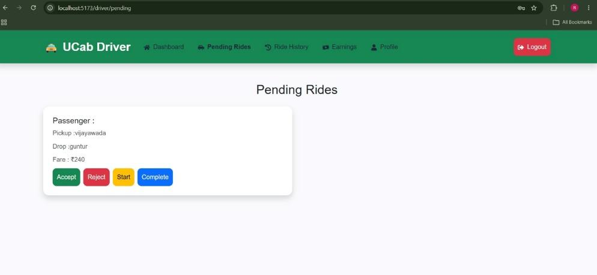
Driver Rides History
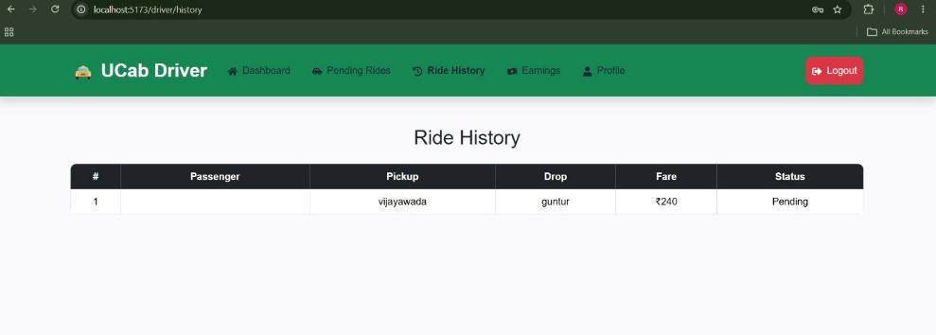
Driver Profile
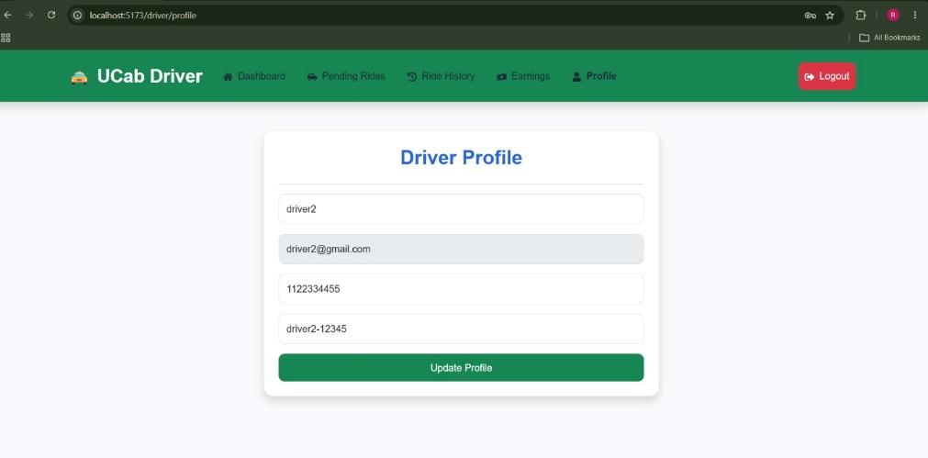
10. Testing :
- Testing Strategy
The Cab Booking System was tested using a combination of manual testing and functional testing to ensure that all modules work correctly and meet the project requirements. Each feature was tested individually and then integrated to verify the complete workflow from user authentication to cab booking and administration.
The testing process focused on validating user inputs, API responses, authentication mechanisms, database operations, and the responsiveness of the user interface. Special attention was given to role-based access control to ensure that Users, Drivers, and Administrators could only access their respective functionalities.
- Tools Used

Tool | Purpose
Google Chrome | Tested the application's functionality and responsiveness.
Postman | Tested REST API endpoints and verified request/response data.
MongoDB Atlas | Verified database records and CRUD operations.
Visual Studio Code | Debugged frontend and backend code.
Browser Developer Tools | Inspected UI elements, network requests, and JavaScript errors.
Git & GitHub | Managed version control and tracked code changes.

- Types of Testing Performed
- Functional Testing: Verified that all features such as login, registration, cab booking, and booking management worked correctly.
- Authentication Testing: Ensured secure login, JWT token generation, and access to protected routes.
- Authorization Testing: Verified role-based access for Users, Drivers, and Admins.
- API Testing: Tested all backend API endpoints using Postman.
- Database Testing: Confirmed successful storage, retrieval, update, and deletion of records in MongoDB.
- Form Validation Testing: Checked required fields, input formats, and validation messages.
- Responsive UI Testing: Verified that the application displayed correctly on different screen sizes.
- Integration Testing: Ensured smooth communication between the React frontend, Express backend, and MongoDB database.
11. Screenshots or Demo
The Demo Video Link of the project
https://drive.google.com/file/d/1CcmNOGz10EJjMwaBLrGYC1uYWmm0gBQo/view?usp=drivesdk

12. Known Issues
Issue | Description
No Real-Time Driver Tracking | The application does not provide live GPS tracking of drivers or rides.
Manual Driver Assignment | Drivers are assigned manually rather than automatically based on availability or proximity.
Limited Payment Integration | Online payment gateways are not integrated; bookings do not support real-time payment processing.
No Ride Fare Estimation | The system does not calculate estimated fares based on distance before booking.
Search and Filter Options | Advanced search and filtering for cabs are limited.

13. Future Enhancements :
Enhancement | Description
Real-Time Driver Tracking | Integrate GPS and Google Maps to allow users to track the live location of their assigned cab throughout the journey.
Online Payment Integration | Add secure payment gateways such as Razorpay or Stripe to enable cashless payments and automatic fare processing.
Automatic Driver Assignment | Implement an algorithm to automatically assign the nearest available driver based on the user's pickup location and driver availability.
Ride Scheduling | Allow users to book rides in advance by selecting a preferred date and time for pickup.
Ratings and Reviews | Enable users to rate drivers and provide feedback after completing a ride, helping maintain service quality.
Admin Analytics Dashboard | Enhance the admin panel with charts and reports displaying booking statistics, revenue, user growth, and driver performance for better decision-making.

